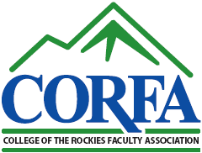
COLLEGE OF THE ROCKIES FACULTY ASSOCIATION
P.O. BOX 8500, 2700 COLLEGE WAY, CRANBROOK, BC V1C 5L7
Telephone: 250.489.8251

FEDERATION OF POST SECONDARY EDUCATORS - LOCAL 6

Policy Updates – April 21, 2016 Annual General Meeting

2. Release Time

Release time for CORFA Liaison
The CORFA Liaison will have 20% release time from September until May of each year. The Liaison position is open to both regular and non-regular faculty members. The duties and scope of the position are to be reviewed annually by a subcommittee of the CORFA Executive.

3. Meetings

Special Events
CORFA may purchase one drink ticket for participating members at a special function that includes a “Wine and Cheese” component. Examples of these events may include Conversation Cafes, joint events with other College groups, or other member engagement activities.

4. Travel and Accommodation

Travel and Per Diem
CORFA will reimburse members following the same per diem and auto rates as FPSE.
Rates as of April 2016 – subject to change.
- Breakfast $12; Lunch $17; Dinner $27
- Incidental $10 per day
- Auto 54¢per kilometre

8. Union Education
Process was approved at the February 2016 general meeting. The Executive is recommending the following:
If funding is approved, and after the event, the member must provide a written report to the CORFA Executive.

